The Logical Journey of the Zoombinis is a long and arduous one. You must help the little Zoombinis to escape from an island that was once a paradise, but became a prison.

The going is often difficult. To help you the Zoombinis have smuggled out this file of information collected by their spies, many of whom risked their lives in the process. Use it wisely and guide the Zoombinis to freedom, and a new found paradise!
Information collated from the Zoombinis by
Nick Packard and Steve Higgins
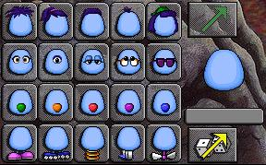

The first job is to choose your team of Zoombinis. You can do this the hard way, or the easy way. The easy way is to press ‘shift’ and click on the dice. You will get 16 randomly selected Zoombinis. Or you can select the attributes for each Zoombini one by one by clicking on the features that you want.
Click here when you have made the Zoombini you want.
Click here to select the features of your Zoombini randomly
Note: With a little practice, you might be able to select Zoombinis with certain features that will make some of the puzzles a bit easier - see if you can devise a strategy!

Your next job is to guide the Zoombinis across the Allergic Cliffs. If one of the cliffs is allergic to one of a Zoombinis attributes, he’ll sneeze you straight off the bridge. But if one cliff is allergic to a Zoombini, the other one won’t be! You have just six chances to get them all across, so use the record sheets below to help you work out which feature each cliff is allergic to!
Use these attribute record cards to mark off which Zoombinis get across safely. It might help you work out what the cliff’s allergy is to.

Don’t forget to clean the card when you have finished!

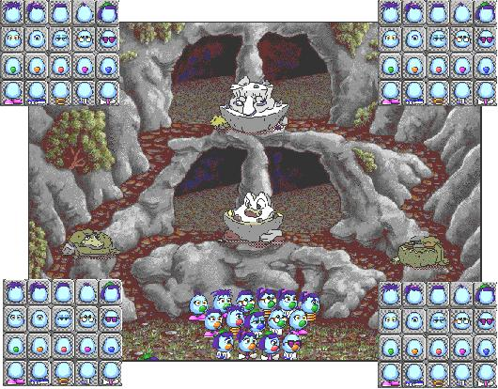

In the Stone Cold Caves, each guard will let only Zoombinis with certain features get past. If one guard won’t let a Zoombini in, the opposite one will.
If it helps, use these attribute record cards to mark off which features the Zoombinis have who get in to each cave. It might help you solve the puzzle more quickly.

Don’t forget to clean the card when you have finished!

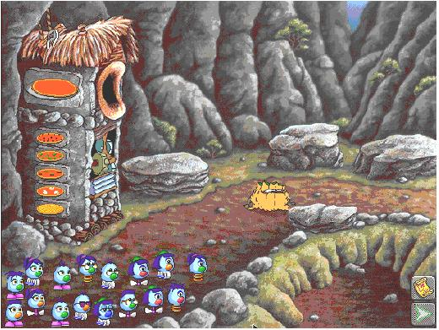
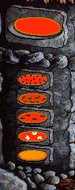
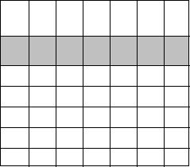

At the Pizza Pass, your Zoombinis have to make a perfect pizza for Arno the Tree Troll or he will not let them pass. You have to help them build the pizza by pressing the buttons on the pizza machine, but beware! Arno is a fussy eater!
If you put on a topping that Arno doesn’t like, he’ll throw it in to the pit. If you build a pizza that only has some of his favourite toppings, he’ll throw it on to the rock behind him. Use the card to record which toppings he likes and which ones he throws away!

Don’t forget to clean the card!

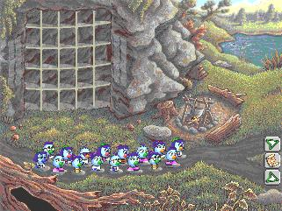

At last you have guided the Zoombinis to a resting place! Before you can continue, you must have at least 16 Zoombinis. Do you have to go back to Zoombini Island to collect some more?
If you need to go and get some more Zoombinis, click here. Click on the picture of the island on the map and this will take you back to Zoombini Island to choose and help rescue 16 more Zoombinis.
When you have 16 Zoombinis, pick which route you want to take. The arrow to the left takes you on the Marshy Trail, the one on the right takes you to the Deep Dark Woods.

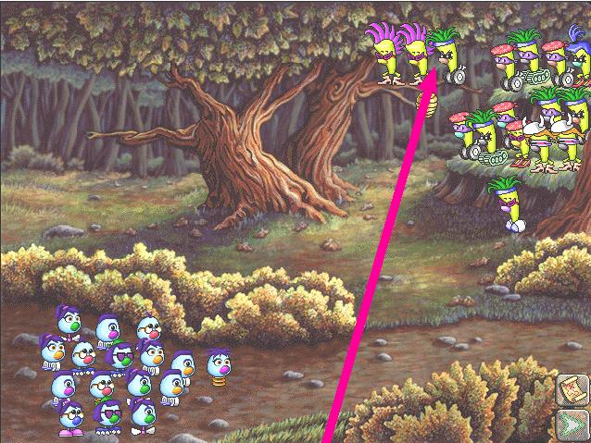

If you have chosen to take the path that leads through the Deep, Dark Forest, your first encounter will be with the Fleens. Each Fleen matches each Zoombini. A Fleen will chase its matching Zoombini!
To get past the Fleens, you will have to get each Fleen that is sitting on the branch to chase a Zoombini. Move one Zoombini forwards and find the spotlight to get a Fleen to chase it. When you get all three off the branch... well, just watch what happens!
The Fleens’ attributes match the Zoombinis’. You might be able to work out which attributes match by counting. Use these charts to record which attributes match up. It might help you work out which Zoombini to use as bait!

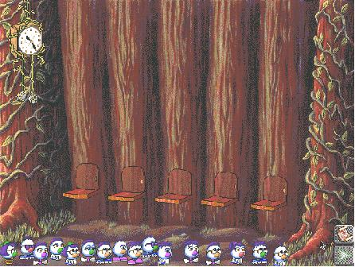

The Didimensional Hotel has plenty of room for everyone, but some Zoombinis can share, others can’t. Who can share with whom is the problem you have to solve. Don’t make too many mistakes or the hotel will close up for the night.
When you arrive, it doesn’t matter who sleeps where, but once a room is taken, things begin to get complicated. There aren’t enough rooms for everyone, so some Zoombinis have to share. Zoombinis who share a room also have to share a common feature or attribute. The trouble is, you don’t know what that attribute is. A little trial and error might give you a few ideas so pick up a Zoombini and show it to its room...

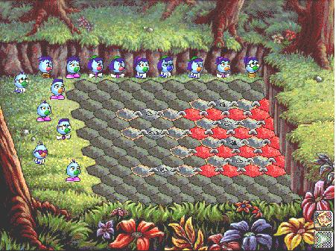

To get the Zoombinis out of the pit you must arrange them on the stones with orange edges. These stones are linked together. Zoombinis that stand on linked stones must share a particular feature...
Two orange edged stones that are linked together must have Zoombinis that share a common feature. If the stone between the two linked stones shows a nose, then the Zoombinis you choose must have the same colour nose and so on. When you have filled all the orange stones, click on the green arrow to see which stones rise!

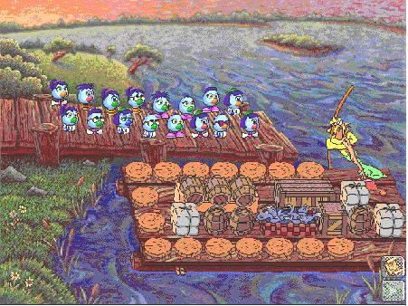

Captain Cajun’s Ferry is the only way across the marsh but, despite what he might tell you, Captain Cajun is very fussy about where everyone sits...
Captain Cajun has a simple rule about who sits where, you can sit anywhere you like as long as you share an attribute with the people sitting on either side of you. Can you arrange the Zoombinis so that they all share at least one attribute with each neighbour?

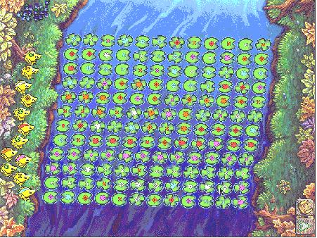

The Titanic Toads will help you across the lily pad puzzle... ... as long as you set them off in the right direction...
You can see a path across the lilies marked by the yellow arrow. It shouldn’t be hard to work out which toad would you place on the first lily pad on this path?
Each toad has a special mark or tattoo. They can only follow a path that carries their own markings. So a toad with an orange stripe will only hop on pads with orange shapes on or a toad marked with a diamond will only hop on lily pads with diamonds on them. Some toads will only hop on certain shaped lily pads.
Each toad will do two journeys for you and carry one Zoombini each time.

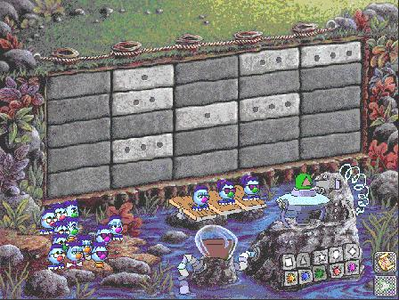

A strange puzzle and an even stranger machine. You have to aim the mudball cannon using colours and shapes as coordinates! Hit a 3 spot brick on the wall to get 3 Zoombinis over the wall. Hit a blank and waste a mudball!
On the mudball cannon, each different colour will point the cannon at a different row and each different shape will point the cannon at a different column. Use a little trial and error to work out which matches which!
Select a different shape or a different colour for each mudball, just click on the colour or shape you want. When you have chosen, click on the little green arrow to launch your mudball! The container on the left holds your ammunition - when it runs out, any Zoombinis not yet over the wall will have to stay behind!

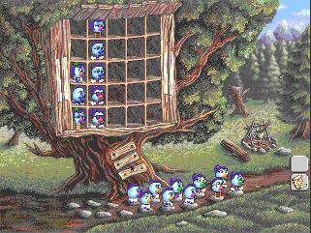

At last you have guided the Zoombinis to a resting place! Before you can continue, you must have at least 16 Zoombinis. Do you have to go back to Zoombini Island to collect some more?
When you have 16 Zoombinis on the stepping stones,
click here to move on.

If you need to go and get some more Zoombinis, click here. Then click on Zoombini Island to choose and rescue 16 more Zoombinis.
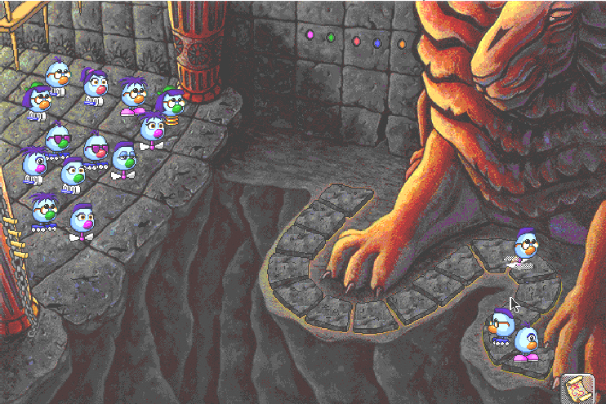

The Lion’s Lair in the Mountains of Despair is a deadly puzzle if you can’t crack the code. Look to the ancient markings on the walls of the lair to find clues to help the Zoombinis on their way!

The Lion’s Lair is fairly easy, once you know how to crack the code. The code always has something to do the the Zoombinis’ attributes, it might be the colour of their noses, or their hair styles, or what kind of feet they have. If you can put the Zoombinis in the right order on the line of stones on the floor, the lion will let you past but beware, sometimes important parts of the puzzle are missing and if you make too many mistakes, Zoombinis might get left behind.
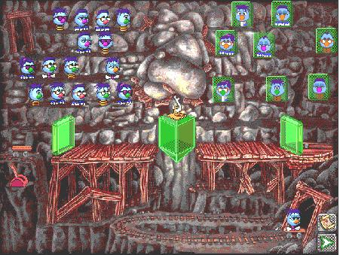

The Mirror Machine can reflect the way you look, but it can also change and distort your appearance. Looks can be deceiving, so beware! A matching reflection will clear the way, but a mistake might cost you dear.
When the going is Not So Easy, the Mirror Machine tells the truth. Can you pick an image from the right hand side of the machine to add to the right hand crystal that exactly matches the features of one of your Zoombinis? If you can, place that Zoombini on the cart, the image on the crystal on the right and then pull the lever.
Later, when the going gets harder, look carefully at the crystal in the centre of the Mirror Machine, for it will start to play evil tricks.

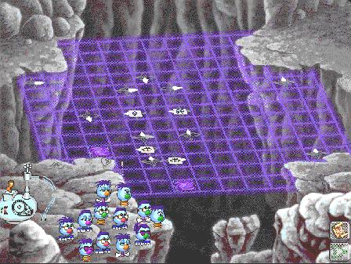
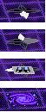

This is the last and most treacherous puzzle of all. Set a Zoombini off on the wrong route and you may lose them into the abyss. Even worse, the route can change before your very eyes, so think carefully before choosing.
Start each Zoombini off on their route here.
The Bubblewonder Abyss is the final, but most puzzling puzzle. You have to pick a route for each Zoombini and, once started, there’s no going back! Travelling in straight lines along the grid, they continue until they bump in to a sign. Different signs can do different things...

Changes the direction as indicated by the white arrow

Change direction but beware, next time the change may be different

This sign only affects Zoombinis with that specific attribute

Danger! What ever you do, don’t send a Zoombini this way.

Congratulations!

You have made it to Zoombiniton for the first time, but there are still many more Zoombinis to be rescued from Zoombini Island. Your next journey may not be a bit trickier! Each time you travel, the puzzles may look the same but little things change to make life a bit harder.

Good luck! You’ll need it if you are going to save all the Zoombinis!

