Notebook

Write your name in the box and save your notebook using the ‘save as’ command

An Allegorical Painting
by
Agnolo Bronzino (1503-1572)

What story do you think Bronzino's picture tells?

Three Similar Paintings

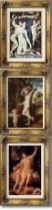 Compare the paintings by Bronzino, Cranach, and Reni:

Can you find three similarities in these three paintings?

The Woman

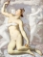 Compare the women in the paintings by Bronzino, Cranach, and Reni:
What is similar about the women?
Can you find differences between the women?

Look closely at the woman in the painting by Bronzino:
What does the woman's tiara tell you about her?

What does the golden apple represent?
Who is the woman pointing to?
Who is the woman?
Can you find three similarities between this medieval picture and the paintings by Bronzino and Cranach?
What does the woman represent?

The Boy
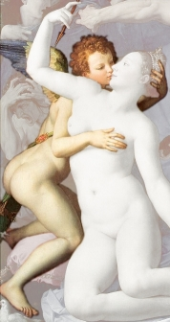 Compare the boys in the paintings by Bronzino, Cranach, and Reni:
What is similar about the three boys?

Can you find three differences in the three boys?

Look closely at the boy in the painting by Bronzino:
Who is the boy?

‘Oddbits’

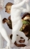 Look closely at the strange female creature in Bronzino’s painting:
What does her face and expression suggest she is like?
What is she holding in her left hand?
What is she holding in her right hand?
What is the connection between the things in her hands?
What is she like if she is part reptile or dragon?
What is she like if she is part lion?
What does this strange female creature represent?

The Two Background Figures

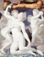 Look closely at the two background figures in Bronzino’s painting:
What are the two background figures each trying to do?
Are they helping each other or are they working against each other?

What has the old man got on his back?
What does his expression suggest about his feelings?
Who could the old man be?

What is strange about the head of the figure on the left?
What emotion is this figure feeling?
What could this mysterious figure represent?

The Smiling Boy

Look closely at the smiling boy in the painting by Bronzino:
What is in the smiling boy’s hands?
What is in the smiling boy’s right foot?
What is the connection between these two things?
What is on the smiling boy’s left ankle?
What does the smiling boy represent?

The Tormented Person

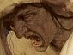 Look closely at the tormented person in the painting by Bronzino:
What does this tormented person represent?

The Whole Picture

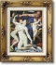 Now you can answer the key question:
What story do you think Bronzino's picture tells?

